TWO STAGE ROTARY WITH ROOTS VACUUM PUMPING SYSTEMS
Over the years, Unique Vacuum Solutions, has expertised in delivering efficient and effective vacuum pumping systems for various industrial applications.
CAPACITY: 1000 LPM Rotary with 250 m3/Hr roots TO 2000 LPM Rotary with 550 m3/Hr roots
ULTIMATE VACUUM : 1x10⁻⁴ mBar

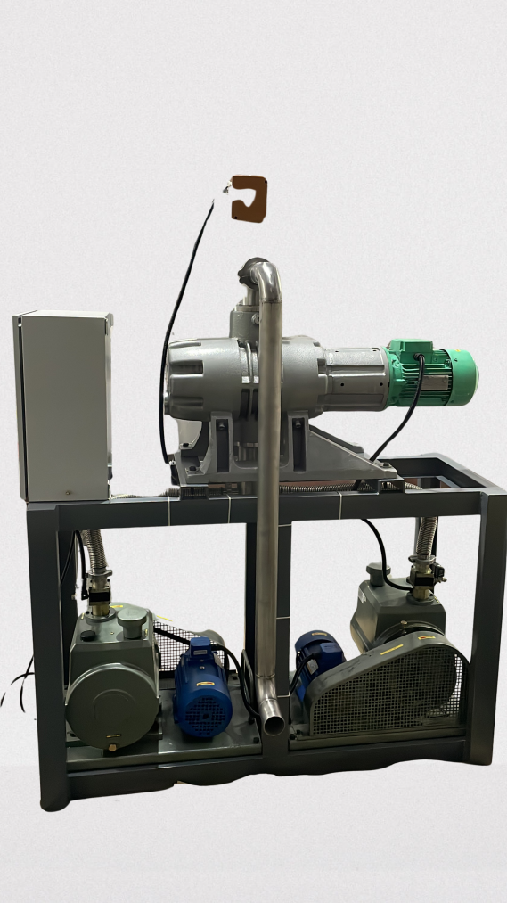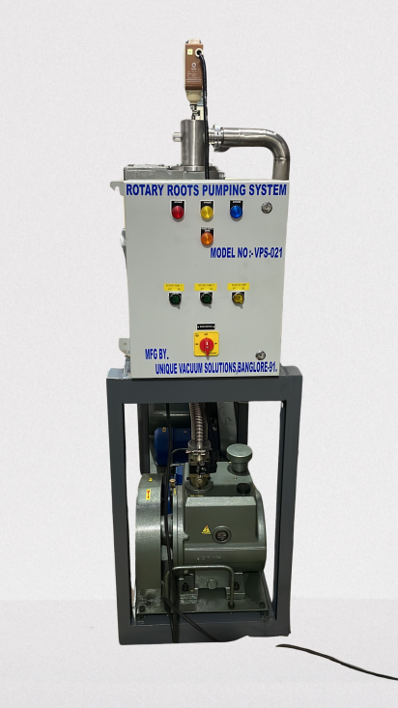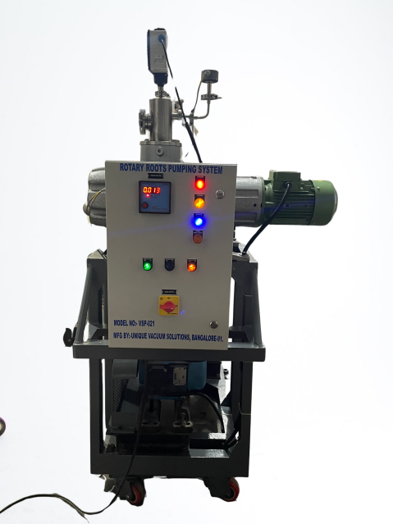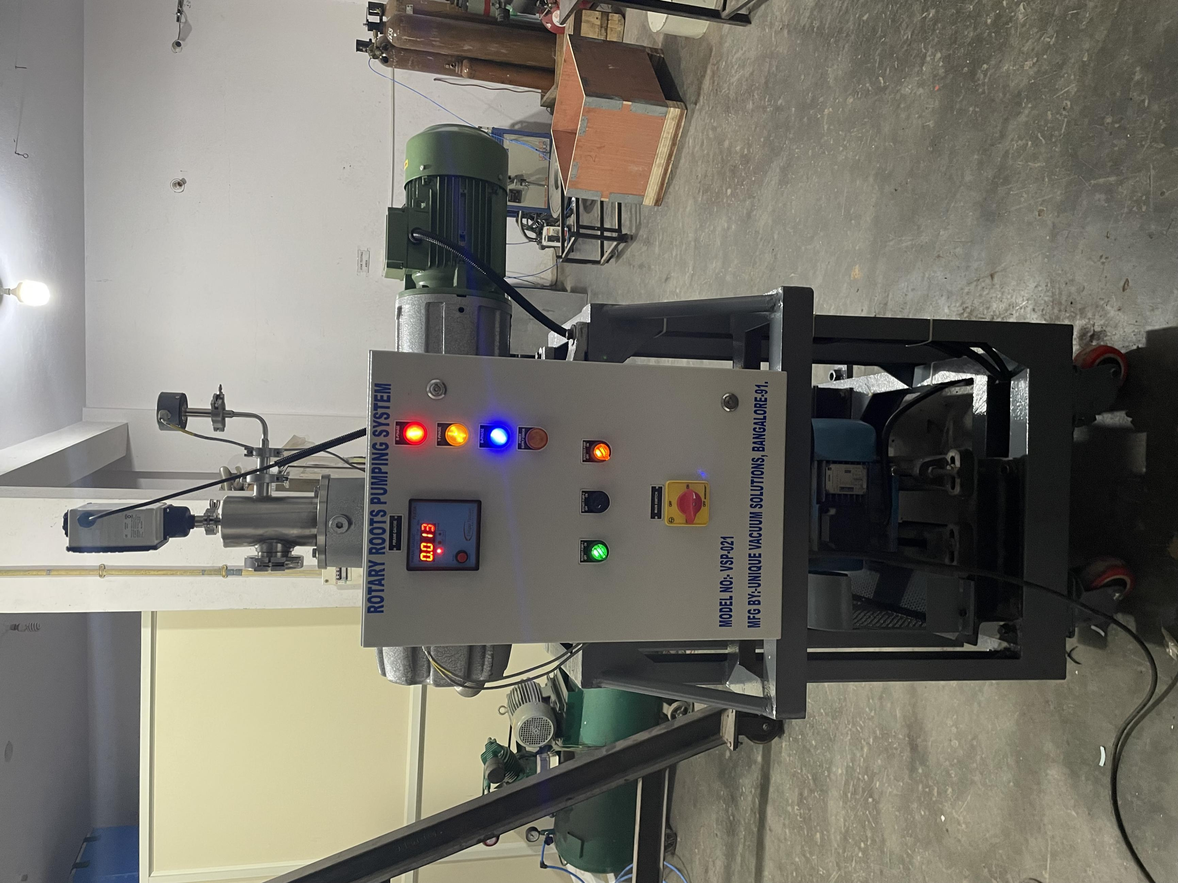
For Cryo lines, cryo cans, cryo cylinders evacuation application ( with liquid notrogen trap and inlines valves and individual line vacuum measusrement.
CAPACITY: 1000 LPM Rotary with 250 m3/Hr roots TO 2000 LPM Rotary with 550 m3/Hr roots
ULTIMATE VACUUM : 1x10⁻⁴ mBar
